Finding factorial using pointer:
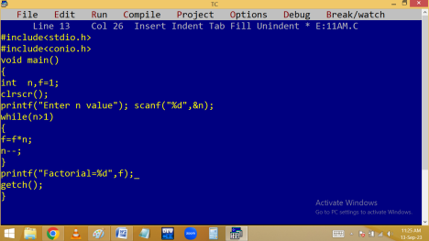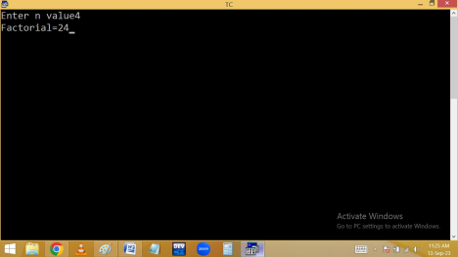
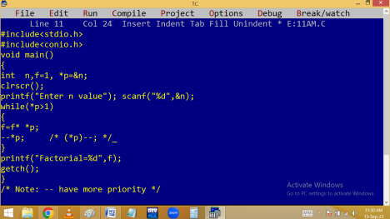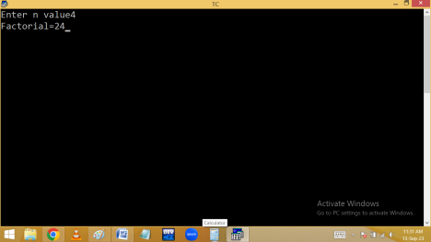Finding a variable value using pointer mechanism:
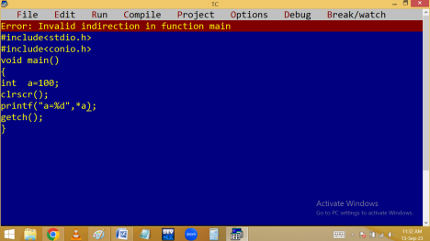
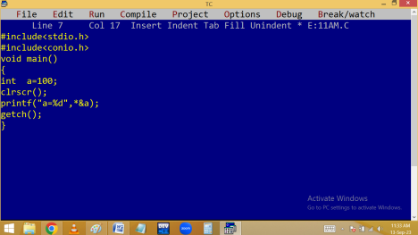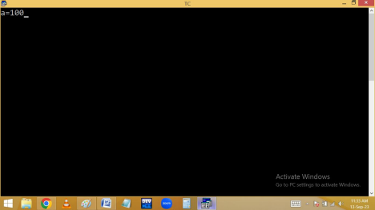Finding pointer size:
Pointer stores address and always address is unsigned int. due to this pointer takes 2 / 4 / 8 bytes in 16 / 32 / 64 bit compilers.
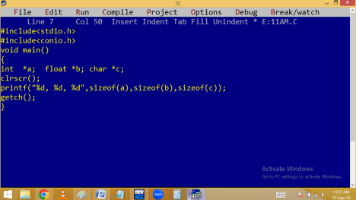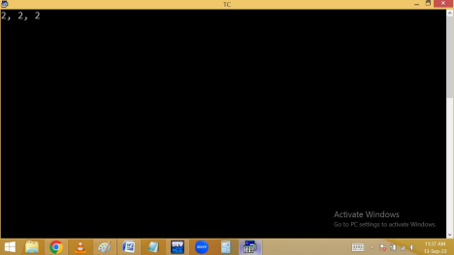Pointer compatibility: pointer stores same type of address only. When different type given, it gives garbage or runtime error.
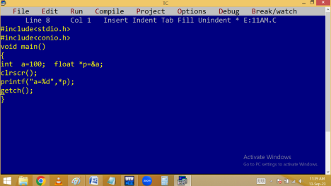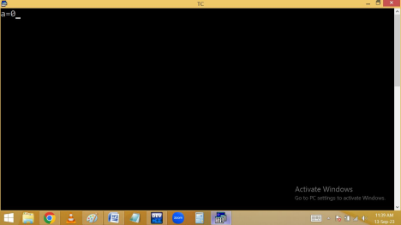
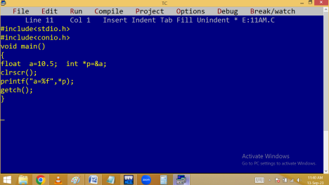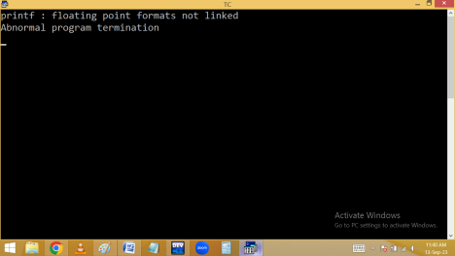Array of pointers: Like normal variables, we can also declare pointer using array. Due to this one pointer able to store several address. It is used to handle dynamic arrays.
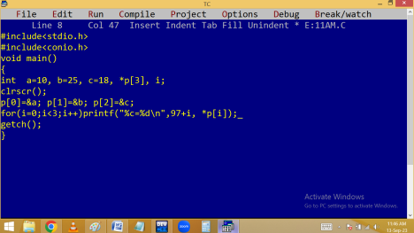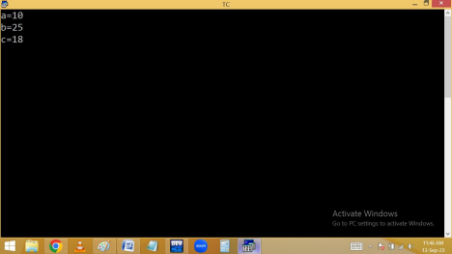Double pointer / pointer to pointer: the pointer which stores the address of another pointer is called double pointer and they are used to manage dynamic multi-dimensional arrays,
Pointer to array:
Array is implicit pointer. Due to this it holds the base cell addr [ 0 cell addr ] implicitly. By assigning the array name or 0 cell addr to the pointer, we can handle array elements using the following syntax.
*(ptrvariable + offset/index * sizeof(variable));
Eg:
int a[3]={10, 25, 18}, *p, i;
p = a ; or p = &a[0]; or p = &a;
for(i=0;i<3;i++)
printf(“%4d”, *(p+i));
Here *(p+i) meaning is:
p is 65500
1. *(p+0*2)🡺*65500🡺value at 65500🡺10 2. *(p+1*2)🡺*65502🡺value at 65502🡺25 3. *(p+2*2)🡺*65504🡺value at 65504🡺18
Note: Here 2 is int size.
Eg:
#include<stdio.h>
#include<conio.h>
void main()
{
int *p, a[3]={10,25,18}, i;
clrscr();
p = a; /* p=&a[0]; or p=&a; */
printf("Elements are: ");
for(i=0;i<3;i++)
printf("%4d",*(p+i));
getch();
}
Output: Elements are: 10 25 18
Note: We can access array elements using array / pointer in following ways.
a[i] / i[a] / p[i] / i[p] / *(p+i) / *(a+i) / *(i+p) / *(i+a)
Pointer to string:
Finding string length using pure pointer mechanism:
Bad / wild pointer: A pointer is declared but not initialized. In this situation the pointer is storing some unknown address and value. This kind of pointer is called bad / wild pointer.
NULL pointer: When a pointer is initialized with 0 or NULL then it is called NULL pointer. To avoid bad and dangling pointers we are using NULL pointer.

